1. Creating and Renaming Files/Directories

Create a directory named test_dir using mkdir.

Inside test_dir, create an empty file called example.txt.

Rename example.txt to renamed_example.txt using mv

**Explanation:**

**mkdir:** Makes a new directory.**touch:** Creates an empty file.**mv:** Renames the file.

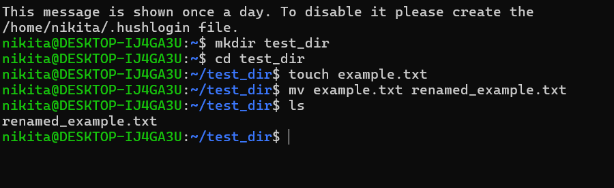

2. Viewing File Contents

Use cat to display the contents of /etc/passwd.

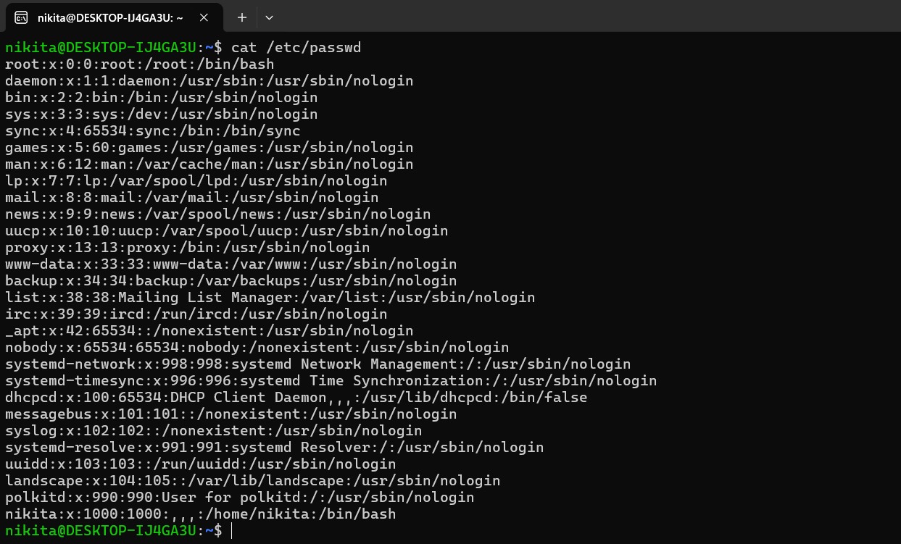

Display only the first 5 lines of /etc/passwd using head.

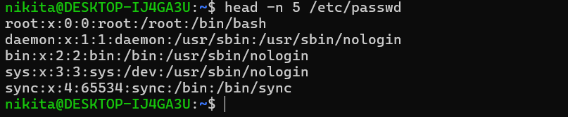

Display only the last 5 lines of /etc/passwd using tail.

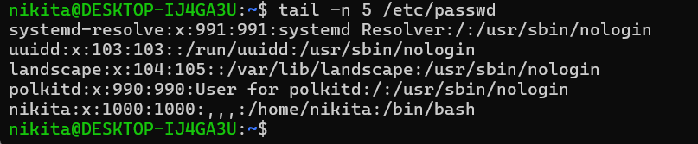

**Explanation:**

**cat:** Displays the entire file.**head -n:** Shows the first 5 lines.**tail -n:** Shows the last 5 lines.

3.Searching for Patterns

Use grep to find all lines containing the word "root" in /etc/passwd.

**Explanation:** grep searches for the term "root" in the file and lists matching lines.

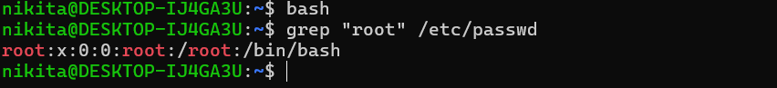

4. Zipping and Unzipping

Compress the test_dir directory into a file named test_dir.zip using zip.

Unzip test_dir.zip into a new directory named unzipped_dir.

**Explanation:**

zip -r compresses the entire directory.unzip extracts the contents to unzipped_dir

zip -r test_dir.zip test_dir

unzip test_dir.zip -d unzipped_dir

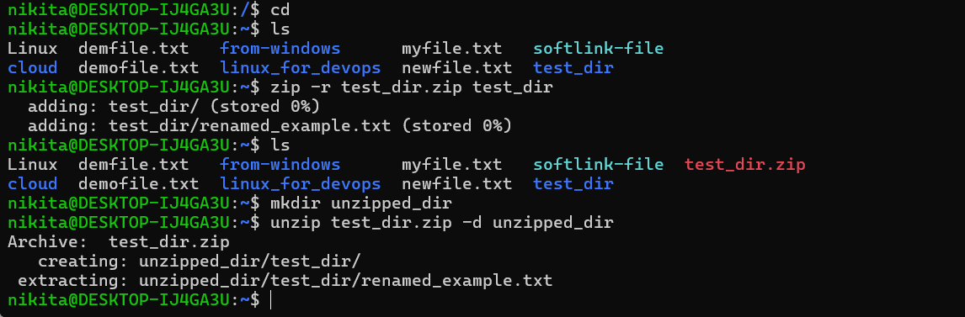



5. Downloading Files

Use wget to download a file from a URL (e.g., <https://example.com/sample.txt>).

**Explanation:** wget downloads a file from the internet.

<https://raw.githubusercontent.com/vincentarelbundock/Rdatasets/master/csv/datasets/airquality.csv>

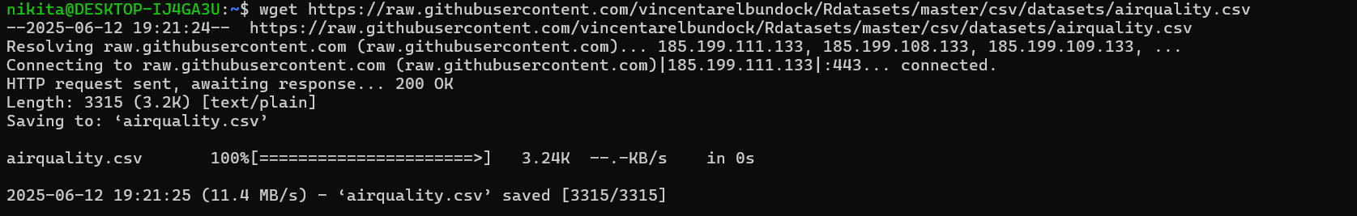

6. Changing Permissions

Create a file named secure.txt and change its permissions to read-only for everyone using chmod.

**Explanation:**

touch secure.txt (**Created the file secure.txt**)

chmod 444 makes the file read-only for owner, group, and others.

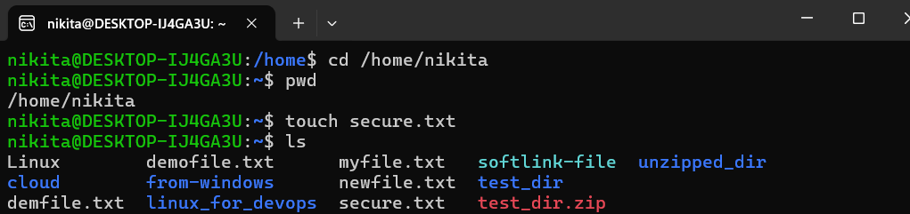

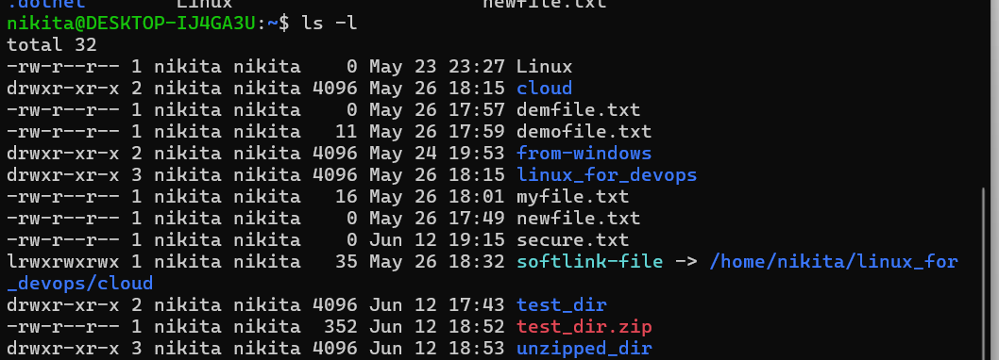

chmod 444 secure.txt (**Set the permissions to read-only**)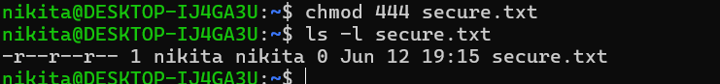

7. Working with Environment Variables

Use export to set a new environment variable called MY_VAR with the value "Hello, Linux!".

**Explanation:**export sets the variable.echo displays its value.

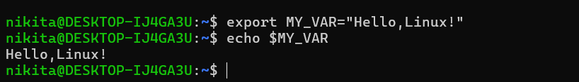

**Submission Guidelines -:** Attach Screenshots or command along with explanation and submit in doc(google doc or microsoft doc) format also attach github repo link